Test Report

Project name: Tikal Academy
Document date: 08.10.2023
Tester: Virlan Alexandru Ionut

-Table of Contents -

1.0 Introduction 3
1.1 Purpose 3
2.0 Test summary 3
2.1 Test type 4
3.0 Test results 7
3.1 Executed test cases 7
3.2 TestLink overview 8
3.3 Graphic charts 8
3.4 Performance testing overview 9
3.5 Console log and Network 12
4.0 Defects 13
4.1 Bugs registered in “Mantis bug tracker” 13
4.2 Graphic Charts 14
5.0 Conclusions 15

Introduction

Purpose

This “Tikal Academy” Test Report serves as a vital communication tool, delivering key information to project stakeholders, enabling them to make informed decisions, assess the quality of the software, and ensure the project's success.
By documenting the testing process, results, and relevant data, a well-crafted test report plays a pivotal role in assuring the software's reliability, identifying areas for improvement, and supporting risk assessment and compliance with industry standards.

Test summary

Project name: Tikal Academy
System Name: Desktop, Laptop, Mobile devices
Version Number: 1.1
Testing Period: 15.10.2023 – 31.10.2023
Deployment Date: 08.10.2023

2.1 Test type

Test Owner: Virlan Alexandru Ionut
Test Date: 15.10.2023 – 31.10.2023

Within the realm of software testing, this report explores various methodologies, including:

- Exploratory Testing
- Functional Testing
- Usability Testing
- Smoke Testing
- Compatibility Testing
- Cross-browser Testing
- UI Testing
- Performance Testing.

These testing types are instrumental in assessing the software's robustness, user-friendliness, functionality, and ability to perform optimally under diverse conditions.

2.2 Test environment
Test Environment |  | Software & Hardware Details
 |  | Software: OS: Windows
 |  | Version: 10 Home 64 bit
 |  | Mozilla Firefox 119.0
 |  | Google Chrome 118.0.5993.118
 |  | Microsoft Edge 118.0.288.76
 |  | Opera 77.0.4054.203
Desktop
 |  | OS: Ubuntu Linux
 |  | Version: Ubuntu 22.04 LTS " Jammy Jellyfish"
 |  | Google Chrome 118.0.5993.118
 |  | Mozilla Firefox 119.0
Opera 77.0.4054.203

Hardware: AMD Ryzen 5 5600x, 4Ghz, 32Gb RAM, AMD Radeon RX 6800 16Gb, Windows 10 Home 64-bit

 |  | Software: OS: Windows
 |  | Version: 10 Home 64 bit
 |  | Mozilla Firefox 119.0
 |  | Google Chrome 118.0.5993.118
 |  | Microsoft Edge 118.0.288.76
 |  | Opera 77.0.4054.203
Laptop
 |  | OS: Ubuntu Linux
 |  | Version: Ubuntu 22.04 LTS " Jammy Jellyfish"
 |  | Google Chrome 118.0.5993.118
 |  | Mozilla Firefox 119.0
Opera 77.0.4054.203
Hardware: AMD Ryzen 5 4600H, 3Ghz, 16Gg RAM, Nvidia GeForce GTX 1650 TI, Windows 10 Pro 64-bit

 |  | Software: OS: IOS
 |  | Version: 17
 |  | Safari 16
 |  | Google Chrome 118.0.5993.118
Mobile devices |  | Mozilla Firefox 119.0  Hardware: iPhone 13 ProMax, iPhone 14, iPad 8
 |  | Software: OS: Android
 |  | Version 14 (Upside Down Cake), Android 11 (Red Velvet Cake)
 |  | Google Chrome 118.0.5993.118
Mozilla Firefox 119.0

Hardware: Samsung 22 Ultra, Samsung Galaxy Tab E, Samsung Galaxy A12

Test results

3.1 Executed test cases

- Functional Testing –

Functionality | Total | Pass | Failed | Blocked | Not run | Defects
Inregistrare | 23 | 18 | 4 | 1 | 0 | 0054707, 0054705, 0054708, 0054709,0054710
Autentificare | 13 | 10 | 1 | 2 | 0 | 0054704,0054711, 0054757
Contul meu | 10 | 10 | 0 | 0 | 0
Adauga in cos | 3 | 3 | 0 | 0 | 0
Cos | 5 | 5 | 0 | 0 | 0
Checkout | 5 | 5 | 0 | 0 | 0
Home page | 38 | 33 | 5 | 0 | 0 | 0054703, 0054734, 0054735, 0054747, 0054749

- Smoke Testing, Compatibility Testing, Interruption Testing, Performance Testing –

Tests | Total | Pass | Failed | Blocked | Not run | Defects
Smoke Testing | 10 | 10 | 0 | 0
Compatibility Testing | 7 | 7 | 0 | 0
Interruption Testing | 3 | 3 | 0 | 0
Performance Testing | 1 | 0 | 1 | 0 |  | 0054706,

A comprehensive examination of the website's functionality was carried out through the execution of 120 test cases, which revealed a commendable success rate with 106 test cases passing and only 14 encountering failure.

3.2 TestLink overview
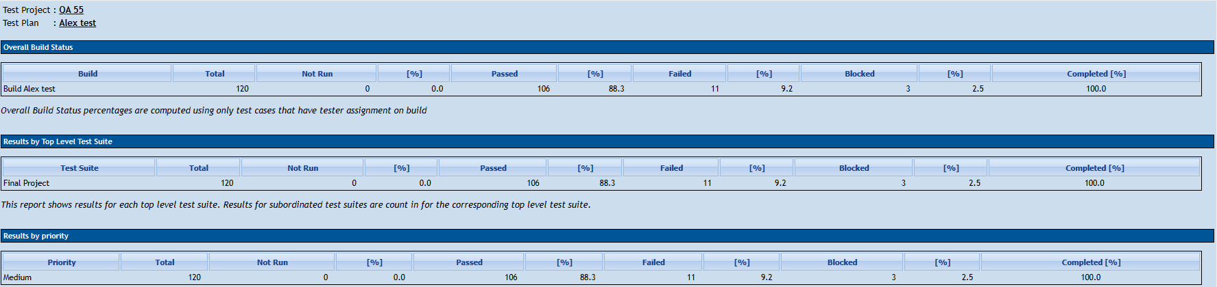

3.3 Graphic charts

3.4 Performance testing overview

Two test sequences were conducted to evaluate the performance. These tests aimed to gauge the system's functionality and responsiveness under varying user loads. The first test was carried out with a single user, while the second test involved a larger group of 10 users.
In the initial test, a single user interacted with the system to assess its behavior and performance when subjected to minimal concurrent usage. This test provided valuable insights into how the system performs under low-impact conditions.

Example 1

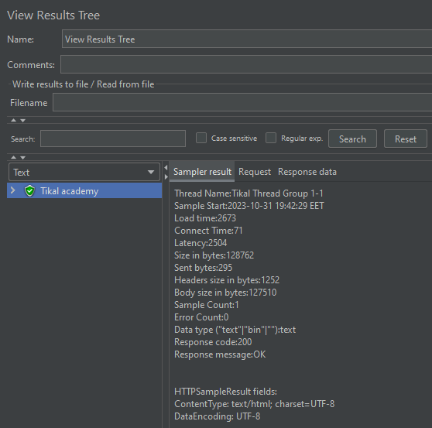

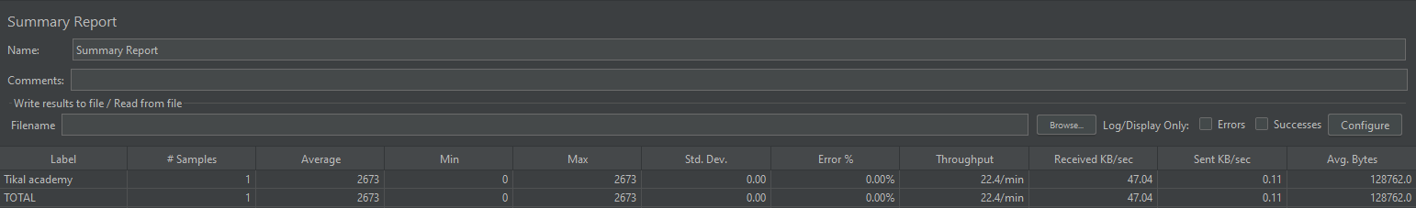

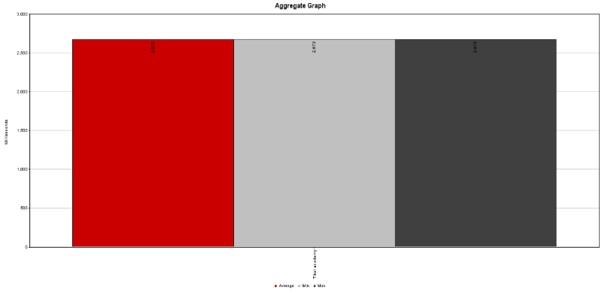

The second test, on the other hand, was conducted with a group of 10 users simultaneously accessing and utilizing the system. This scenario simulated a higher level of user activity, reflecting a more realistic usage pattern and potential stress on the system.

The goal of this test was to assess how well the system handled multiple concurrent users and whether it continued to operate efficiently, meeting the desired performance benchmarks.

Example 2
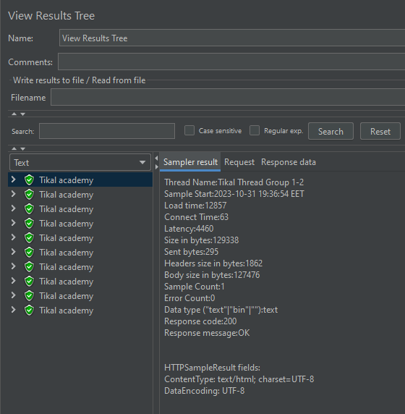
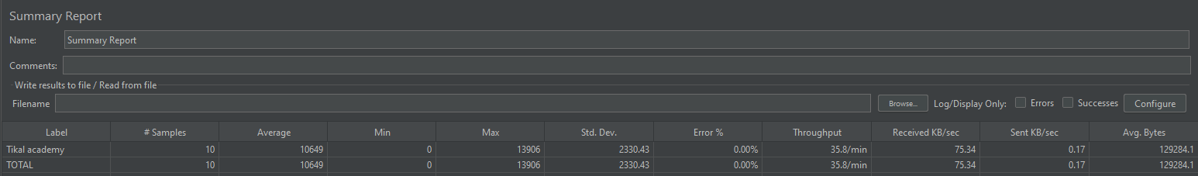
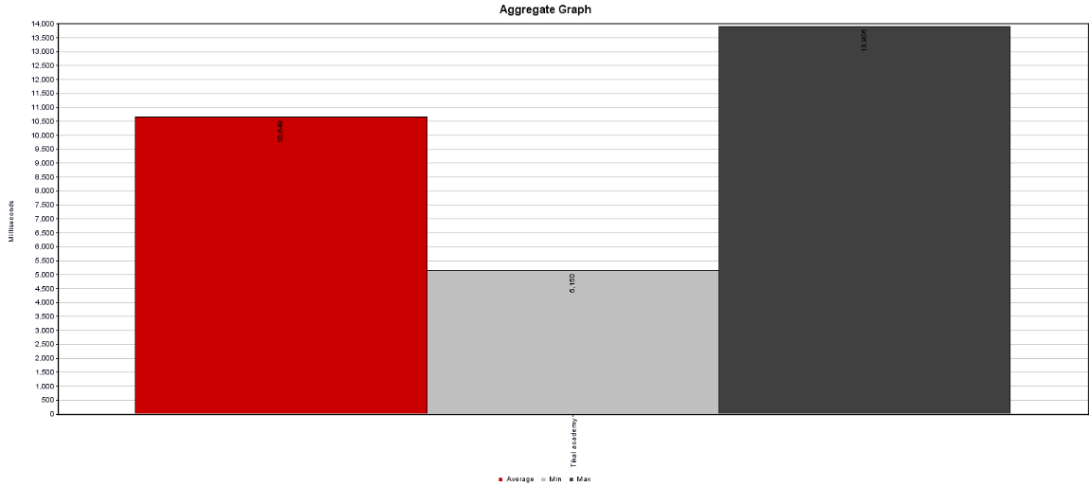

3.5 Console log and Network

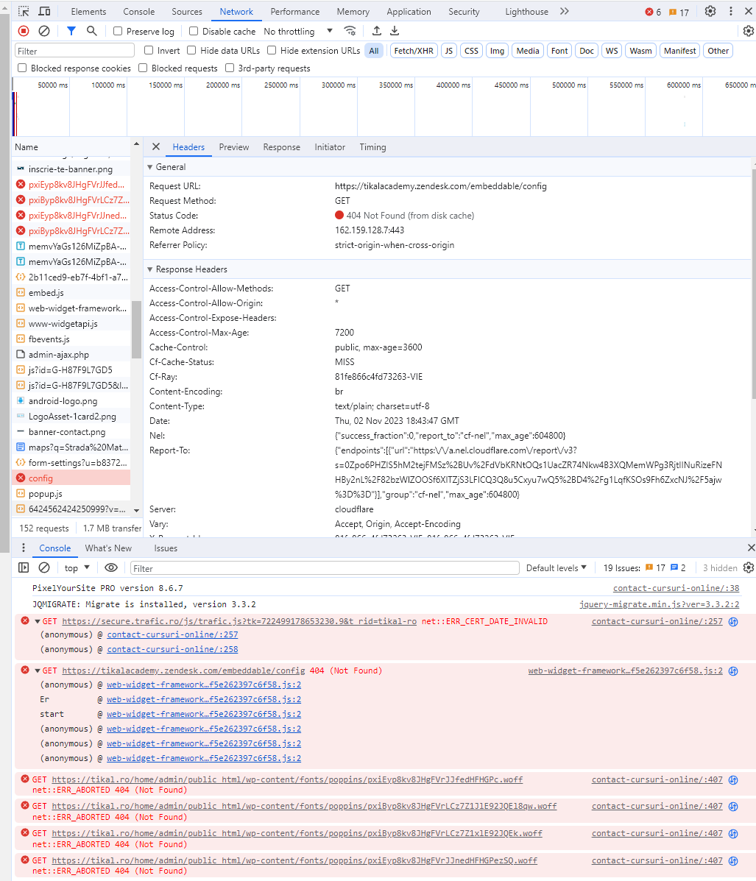

Defects

4.1 Bugs registered in “Mantis bug tracker”

Defect ID | Defect summary | Severity
0054710 | [Inregistrare]-User receives an error message when he tries to register with a correct result inputted into the special field | Blocker
0054757 | [Ti-ai uitat parola?]-User is not able to reset his account password due to an error message | Blocker
0054711 | [Log out]-User is not able to log out from the account | Blocker
0054704 | [Data base connection]-User is not able to connect to the account | Critical
0054706 | [Performance]-User is not able to navigate quickly on the website | Major
0054703 | [Subscribe newsletter]-User can't see an error message when inputs an invalid email | Normal
0054707 | [Inregistrare]-User is not receiving any error message when he tries to register with a one letter user name | Normal
0054735 | [INSCRIE-TE ACUM]-User is not receiving an error message when he tries to use numeric characters in the "Nume" field | Normal
0054747 | [INSCRIE-TE ACUM]-User is not receiving an error message when he tries to use alphanumeric characters in the "Nume" field | Normal
0054749 | [INSCRIE-TE ACUM]-User is not receiving an error message when he tries to use an invalid e-mail | Normal
0054705 | [Inregistrare]-User is not receiving any error message when he tries to register with an invalid e-mail | Normal
0054708 | [Inregistrare]-User is not receiving any error message when he registers with a user name that has more than 40 characters | Normal
0054709 | [Inregistrare]-User is not receiving any error message when he tries to register with an invalid password | Normal
0054734 | [CURSURI]-User is not able to see all content from “Cursuri” section | Minor

4.2 Graphic Charts

5.0 Conclusions

- A comprehensive examination of the website's functionality was carried out through the execution of 120 test cases, which revealed a commendable success rate with 106 test cases passing and only 14 encountering failure.
- These test cases, coupled with the rigorous application of Exploratory and Negative Testing, identified a total of 14 bugs, spanning different severity levels, including 8 normal, 1 minor, 1 critical, 1 major, and 3 blocker issues.
- Furthermore, the imperative requirement for Performance Testing was demonstrated to assess the application's load time effectively.
- A diversity of data type was used during testing: Valid data, Invalid data, No data, and Boundary data.
- It is evident that addressing at least the blocker and major bugs is highly recommended to enhance the overall stability and functionality of the website.

